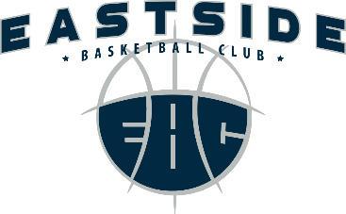
EBC Spring 2017 Tryouts

EBC is excited to announce our 2017 spring tryouts beginning February 26th-March 8th. Our tryout registration link and tryout schedule can be found on our website at www.eastsidebasketballclub.org as well as below.
We would like to ask all current team members that plan on continuing in the spring to register for tryouts as soon as possible. It will help coaches tremendously in determining what team and coaching needs we may have.

There will be a $10 non-refundable tryout fee.

Tryout registration link:
https://tms.ezfacility.com/OnlineRegistrations/Register.aspx?CompanyID=1170&GroupID=1760572

Sunday, February 26th-
▪4:00-6:00pm: High School Girls [grades 9-11]
▪6:30-8:30pm: High School Boys [grades 9-12]
High School players who are not participating in the WIAA HS State Tournament should not try out this day but should ATTEND. Additionally, those same players who are going to state with their respective high school teams are to tryout on March 8th. Please email ncrossan@eastsidebasketballclub.org if your son/daughter will be trying out on March 8th.

Monday, February 27th-
▪6:15-7:30pm: 3rd grade boys + 4th grade boys
▪7:30-9:00pm: 7th grade boys

Tuesday, February 28th-
▪6:15-7:45pm: 8th grade boys
▪7:45-9:00pm: 8th grade girls

Wednesday, March 1st-
▪5:00-6:30pm: 4th grade girls + 5th grade girls
▪6:45-8:15pm: 6th grade girls + 7th grade girls

Thursday, March 2nd-
▪6:15-7:30pm: 5th grade boys + 6th grade boys
▪7:30-9:00pm: ALTERNATE TRYOUTS [All Grades]

Wednesday, March 8th-
▪4:30-5:30pm: High School Boys
▪5:30-6:30pm: High School Girls
6:45-8:00pm: LAST CHANCE TRYOUTS [ALL GRADES]

Please email ncrossan@eastsidebasketballclub.org if your son/daughter will be attending alternates.

